GAME FACT SHEET

ROPE
GAME NAME
ROMANIA
COUNTRY
GOAL
Promoting networking skills in organized ad-hoc groups, stimulating outdoor physical activity and encouraging the development of all types of intelligence (linguistic, musical, logical-mathematical, spatial, body-kinesthetic, personal and social).

OBJECTIVE 2
Development of children's motor skills and abilities, attention and concentration, in order to promote a healthy lifestyle

OBJECTIVE 3

Stimulating multiple intelligences, ENCOURAGING THE SPIRIT OF COMPETITION and fair play.

OBJECTIVE 1
AWARENESS OF THE IMPORTANCE OF PROTECTING THE ENVIRONMENT BY PRACTICING OUTDOOR ACTIVITIES
OBJECTIVES (MAX. 3)

Students are divided into two groups (preferably with balanced physical qualities). The teams sit on either side of the string in a row. Students are distributed in equal numbers girls/boys or mixed and homogeneous in terms of motor skills (to avoid an unbalanced confrontation) and will provide the grip with both hands, on the rope segment reserved for the team. A line is drawn between the two teams.
The middle of the string will be marked by tying a distinctive sign (scarf or colored adhesive tape), which, at the beginning of the game, will be located next to the mark/object placed on the ground
Hold one end of the string at a time, and the rest of the team will sit in the back, catching the front one by the middle. At a signal from the instructor, both teams shoot hard. The team that crosses the line first will lose.

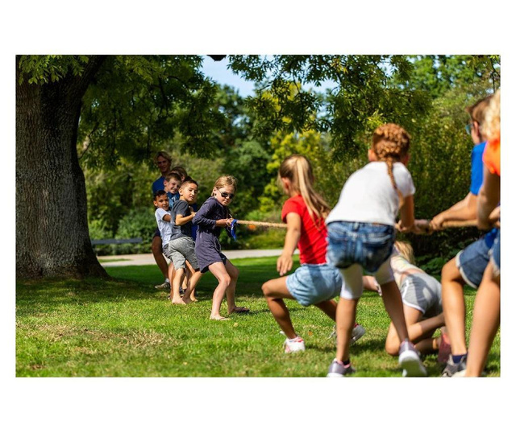
GAME DESCRIPTION (max 4000 characters)
MATERIALS NEEDED FOR THE GAME
Chalk, stone

Until a winner is designated
DURATION / PLAYING TIME

COVERAGE AREA
YES

REGIONAL
LOCAL
NATIONAL
VENUE

YES
OUTDOOR

MOUNTAIN

SEA

FOREST
YES
PARK
YES
SPORTS FACILITY

PERIOD / SEASON OF DEPLOYMENT

YES
WINTER
SUMMER

GAME TYPE AND PRACTITIONERS
PERIO PERIOD / SEASON OF DEPLOYMENT
ADA / SEASON OF DEPLOYMENT

TEAMS
YES
INDIVIDUAL
yes
MIXED

FEMININE

MASCULINE

AGE CATEGORIES

OVER 19 YEARS OLD

15 – 18 YEARS
YES
11- 14 YEARS
YES
6 – 10 YEARS
OBSERVATIONS

