GAME FACT SHEET

HOPSCOTCH
GAME NAME
ROMANIA
COUNTRY
GOAL
Promoting networking skills in organized ad hoc groups, stimulating outdoor physical activity and encouraging the development of all types of intelligence (linguistic, musical, logical-mathematical, spatial, body kinesthetic, personal and social).

OBJECTIVE 2
Development of children's motor skills and abilities, attention and concentration, in order to promote a healthy lifestyle

OBJECTIVE 3

Stimulating multiple intelligences, ENCOURAGING THE SPIRIT OF COMPETITION and fair play.

OBJECTIVE 1
AWARENESS OF THE IMPORTANCE OF PROTECTING THE ENVIRONMENT BY PRACTICING OUTDOOR ACTIVITIES
OBJECTIVES (MAX. 3)

Hopscotch is a classic game that can be practiced both outdoors and indoors, if we have enough space and a little goodwill.
The minimum number of players is two, not having a maximum number. Obviously, the more players there are, the longer it will take.
To play hopscotch we need a stone with which to throw to hopscotch, a place (smooth and without potholes) on the asphalt and chalk to draw playing space. Depending on the area, it can look different ways, it can be longer or shorter, more complex or simpler.
In all cases the idea is essentially the same: a few boxes numbered ascending starting with the number 1.
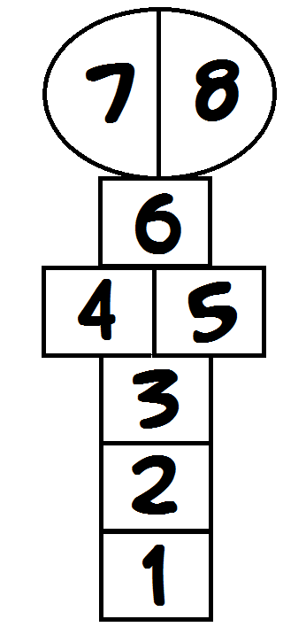The boxes have to be walked from 1 to 8 and then back to 1. Whoever manages to go through them all first, wins. However, the game continues until all players manage to go through hopscotch. If the stone falls outside or on the line of the box you go to retrieve your stone and give way to the next player. In the fortunate event that the stone fell into the little house where you had to jump on one leg, from square to square without touching a line. If you hit the line or, worse, jump out or into another square, you give way to the next player. It is worth mentioning that where there are two squares in the same row, you have to jump one square in each square. With a little house before the square where the stone is, you stop, stand on one leg and try to take the stone. If you succeed, you go back to the beginning and throw a stone at the next house.

GAME DESCRIPTION (max 4000 characters)
MATERIALS NEEDED FOR THE GAME
Chalk, stone

Until a winner is designated
DURATION / PLAYING TIME

COVERAGE AREA
YES

REGIONAL
LOCAL
NATIONAL
VENUE

YES
OUTDOOR

MOUNTAIN

SEA

FOREST
YES
PARK
YES
SPORTS FACILITY

PERIOD / SEASON OF DEPLOYMENT

YES
WINTER
SUMMER

GAME TYPE AND PRACTITIONERS
PERIO PERIOD / SEASON OF DEPLOYMENT
ADA / SEASON OF DEPLOYMENT

TEAMS
YES
INDIVIDUAL
yes
MIXED

FEMININE

MASCULINE

AGE CATEGORIES

OVER 19 YEARS OLD

15 – 18 YEARS
YES
11- 14 YEARS
YES
6 – 10 YEARS
OBSERVATIONS

